4344 Laurel Canyon suite 4
Studio City Ca. 91604

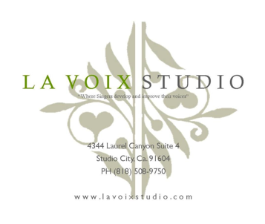
L a V o i x S t u d i o
Subject: Rules AND REGULATIONS

for the Freda and scherrie Payne

scholarships for Youth and adult singers 2019 - 2020

To all candidates and possible recipients, the rules and regulations for “The Freda and Scherrie Payne Scholarship for Youth/ Adult Singers 2019 - 2020” are as follows:
- All three scholarships shall be the length of a term of six months (24-30 weeks), excluding all holidays or vacation days for our staff. Valid through December 1, 2019 to December 31, 2020 and but only valid during their six-month scholarship term (e.g. Dec 1 – Jun 30, Jun 1 – Dec 31) and must reapply for any additional scholarships.
- All three scholarships will be for a half an hour/30-minute lesson once a week at the recipient’s scholarship rate. It is at the discretion of the teacher to allow scheduling for more lessons in week (at the regular rate).
- If a recipient misses their lesson, there are no make-up lessons. Recipients must abide by the 24-hour studio cancellation policy. If a recipient cancels their lesson less than 24 hours’ notice, more than 5 times, they may be subject to forfeit their scholarship.
- All partial payments must be made at the beginning, the first week, of each month.
  - 50 percent scholarship- $37.50 per half an hour lesson
  - 75 percent scholarship- $18.75 per half an hour lesson
- All partial payments must be paid for each lesson by the number of weeks in that particular month.
  - E.g. 50 percent scholarship- $37.50 x 4 weeks= $150.00
  - E.g. 50 percent scholarship- $37.50 x 5 weeks= $187.50
  - E.g. 75 percent scholarship- $18.75 x 4 weeks= $75.00
  - E.g. 75 percent scholarship- $18.75 x 5 weeks= $93.75
- The scholarship is not redeemable for cash or money back. The scholarship is not transferable and cannot be shared with another person(s). The scholarship can only be accepted/ credited or used at La Voix Studio with their current vocal instructors.
- The scholarship only applies to private lessons or online Skype lessons and does not apply to classes (group sessions, master-classes, sight-reading classes, performance/singer’s/introductory workshops, music instrument lessons, etc…)
- All recipients must agree and sign these terms. By signing this agreement of terms, the recipient agrees to follow these regulations or will have to forfeit their scholarship. If one does not agree, the recipient(s) must withdraw his or her bid and it would be at the studio’s discretion to either choose another recipient, or, let the position remain available until the next drawing of scholarships the follow scholarship term and/or year.
- La Voix Studio reserves the right to change the terms, rules, regulations and/or scholarships at any time.
Please sign below to acknowledge that you understand and agree to the terms and regulations above.

Applicant Name ________________________________________________________ Phone ________________________
Applicant Signature ______________________________________________________ Date _________________________
Parent/ Guardian Name __________________________________________________ Phone ________________________
Parent/ Guardian Signature ________________________________________________ Date _________________________

* If you have any further questions about the student scholarships and/or how they apply, please contact our office at 818 508 9750 or student.scholarships@lavoixstudio.com.

